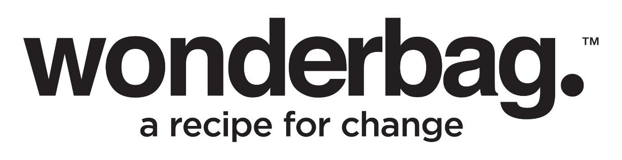

Press Release
For Immediate Release

Women at the heart of empowering change and entrepreneurship with Wonderbag

From the 24th August 2023 until the end of Women’s Month, Wonderbag are launching a special deal where the public can order two Wonderbags for only R121 through www.mywonderbag.co.za, including delivery to a Pargo pick up point of your choice. The concept behind the women-centric campaign was conceptualised by Wonderbag’s special projects team leader, Cindy-Lynn Vester, who coined the initiative as being about, “we stand ONE TWO ONE, as South African women, walking side by side” – in the hopes to assist fellow South African women through this campaign, hence the specific R121 price point.

Staying true to the essence of the Wonderbag brand that hold women at the heart of who they are as a business, this recent Wonderbag initiative is one of a few that the Wonderbag team have rolled out in August 2023. Also being carried out during Women's Month by the Wonderbag team, has been a forward-reaching initiative through their Wonder Women network that aims to establish a cycle of Women empowerment within communities.

“Our network of Wonder Women will be given Shoprite vouchers to purchase ingredients and prepare nourishing meals for fellow women, showcasing the benefits of cooking in a Wonderbag – especially for those who use wood, paraffin and electricity as their main source of energy to cook,” explains Collins.

Sarah Collins, the Founder of Wonderbag, has been a relentless advocate for women's empowerment, creating over 20,000 entrepreneurial opportunities for “Wonder Women” living in rural communities. Praisemore Mhlanga, based in Cape Town, is one of these many inspiring Wonder Women who has walked an incredible journey from hardship to hope.

Praisemore and her husband started their life together in a humble single-room dwelling, living in Zimbabwe. In 2009, she took a leap of faith and followed her husband Tapiwa to Cape Town, with dreams of a better life and began selling curtains door-to-door, using the sewing skills she had learned on her mother's hand-powered sewing machine. Her determination drove her small business to grow, expanding to include bedspreads and couch covers. Eventually, she joined a stokvel with other women in the community, which enabled her husband to purchase their first car, marking a significant milestone in their journey.

In 2021, Sarah Collins visited Cape Town and met Praisemore and her husband through a mutual friend. Due to the growing demand for Wonderbags in the Cape region, a few months after returning to KZN, Sarah decided to establish a bigger and more permanent footprint in the Western Cape through the Clothing, Manufacturing and Textile (CMT) process and in the process hired Tapiwa as a driver. His job was to deliver textile material and resources to people within the rural communities. Praisemore was soon presented with an opportunity to produce Wonderbags due to her sewing expertise. Eager to embrace the chance to make a positive impact in her home and within the community, she quickly secured premises and hired eight females whom she taught the art of sewing. Together they produced around 300 Wonderbags a week.

A few months later, Praisemore saw their Wonderbag production increase to over 500 bags weekly. The couple soon moved into their new house, signed a lease for larger premises, and provided employment to fifteen more ladies - all of which now play a leading role in supporting their families, helping their children access education, and providing much-needed support to elderly parents.

Reflecting on her early struggles and growth, she recalled, “It was a tough journey and I wanted to quit because at the beginning the fear of making mistakes overwhelmed me. The team encouraged me to learn from them and grow. Aunty Sarah has given me confidence. I am very grateful and now believe that it’s possible to sew 20,000 Wonderbags a month! To make 5,000 bags per week, we will need resources such as sewing machines, raw materials, and more people. We want to help others the way that Wonderbag has helped us.”

The Wonderbag not only revolutionises cooking practices but also ensures affordability and accessibility for women across Africa. It offers numerous benefits, including time-saving, reduced energy consumption, increased safety, a healthier environment, and the preparation of delicious and nutritious meals. By liberating women from spending hours cooking over open fires, Wonderbag promotes economic inclusion and empowers them to pursue entrepreneurial endeavors.

Praisemore’s inspiring journey came full circle, with Tapiwa now supporting and embracing her dreams, just as she had followed him to Cape Town years before. Her story is an example of the resilient nature of true Wonder Women, who inspire us all to create a world of opportunity, equality, and empowerment. Through her journey with Wonderbag, she has not only woven a better life for her family but also woven hope and prosperity for many others in her community.

To support the Wonder Women initiatives in August and empower even more Wonder Women in rural communities, visit www.mywonderbag.co.za or www.wonderbagworld.co.za.

Instagram: @TheWonderbag
Facebook: Facebook.com/TheWonderbag
Twitter: @WonderbagO

ENDS

WORDS  PICTURES  DISTRIBUTED  DATE | :  :  :  : | 812  Images of Wonderbags being used and image of Praisemore and Sarah Collins  On behalf of Wonderbag  August 2023

Notes to Editor:

About Wonderbag: The Wonderbag is a revolutionary, non-electric, heat retention cooker that allows food that has been brought to the boil by conventional methods, to continue cooking for up to 8 hours, without using an additional energy source. Not only is the Wonderbag a revolution in the kitchen, but it is also a recipe for social change. The world has embraced the Wonderbag because of its environmental attributes and particularly its social contributions – that includes it being coined by carbon and climate change experts as, “the only scalable carbon offset project in existence”.

Wonderbag is one of the fastest growing registered carbon projects in Africa and is changing the model of aid as we know it. In South Africa, Natural Balance has registered the Wonderbag project as a carbon offset project, unique to any other carbon offset project in South Africa. The Wonderbag offset has significant sustainable development benefits.

Wonderbag was founded in South Africa in 2008 by local entrepreneur and social activist, Sarah Collins, and the product was born out of a practical desire to continue cooking during a bout of Eskom load shedding. Since opening its doors, the company has grown exponentially, and this local product has crossed over borders into various overseas markets.

Using the Wonderbag is simple and convenient, just follow these steps:
- Bring the food to a boil on a stove and let it simmer.
- Place a tea towel at the bottom of your Wonderbag.
- Carefully put the pot with its lid on into the Wonderbag.
- Close the Wonderbag tightly using the drawstring.
- Allow your food to cook to perfection for up to 8 hours.
Below are some guidelines of the recommended cooking times which will assist with planning your cooking according to loadshedding schedules :

Type of food | Boil time | Wonderbag cooking time
Chicken and meat on the bone | 15-30 minutes | At least 2 hours (the longer the more tender)
Boneless/skinless chicken and meat | 10-15 minutes | At least 1 hour (the longer the more tender)
Rice (white, brown) | 5 minutes | At least 45 minutes
Pre-soaked dried beans | 15 minutes | Small beans: 2-3 hours; Large beans: 4-5 hours.
Root vegetables | 15 minutes | At least 1 hour

For more information or visuals, please contact Janna Strang on
janna@rainmakermarketing.co.za / 082 551 3865 or email tasha@rainmakermarketing.co.za

